Cloning into production
List -> Employees -> Employees:

Password: 1ntegrate-Pluto
- Define the account where the system is going to work:
Every NSPOS has a user account, usually starts with RAPOS
Entro al record de NSPOS integration employee,
Change the email:
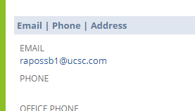
And set the password to default: “1ntegrate-Pluto” when they are done
Setup -> Company -> general preferences:
Tab custom preferences.
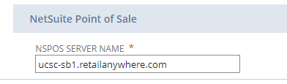
Tomamos el server name ahi, y we provide the customer this sandbox link:
ucsc-sb1.retailanywhere.com
Production is probably: ucsc.retailanywhere.com.

- Now that we have this info, we can file a task, go back to my netsuite inc account, and pick Consultant RA
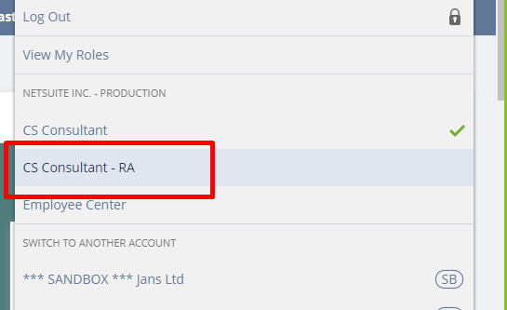
To file a task Customers -> Customer Service -> Issues -> New
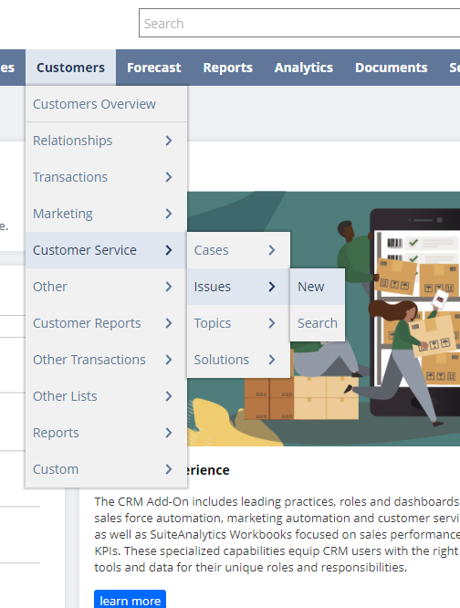
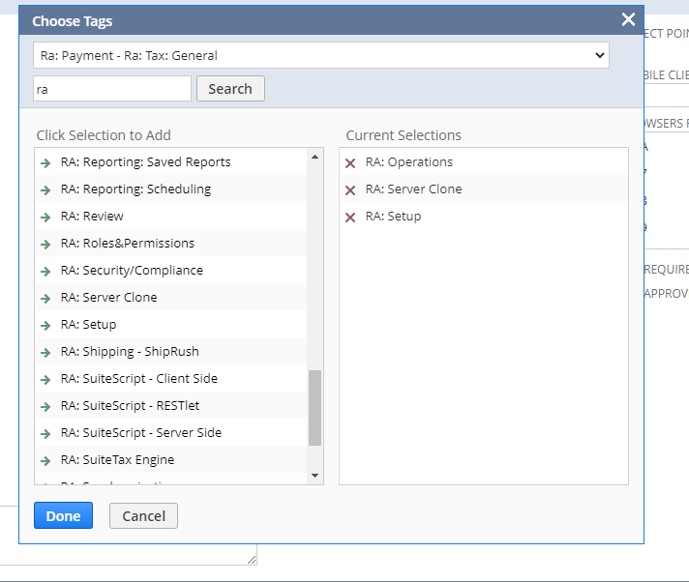
We asked them to do this work, creating a file of a task to let them know to do this.

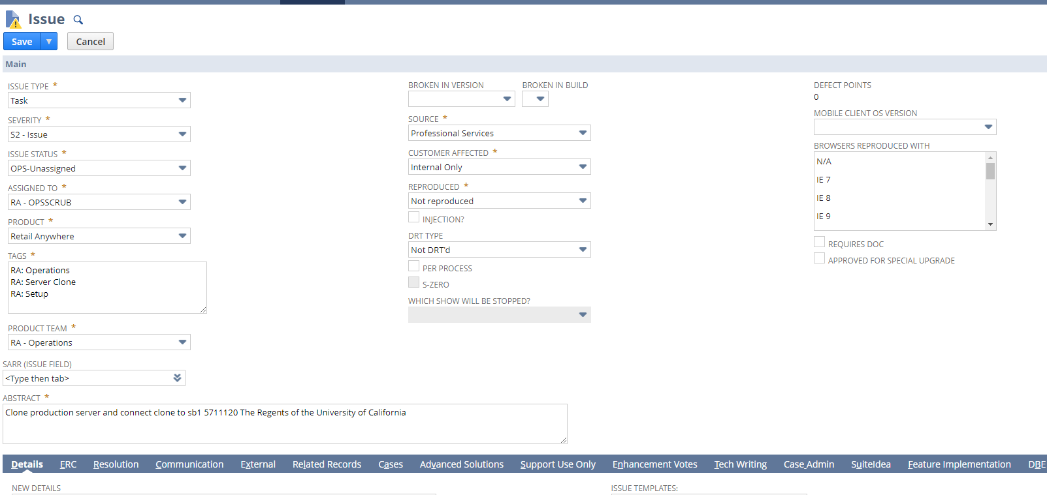
From the customer:
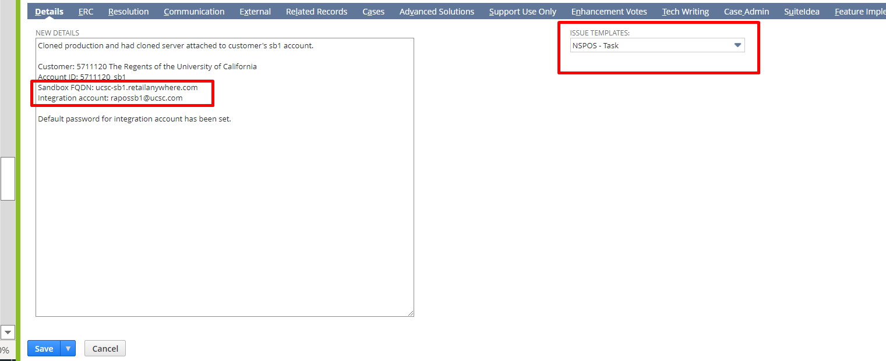
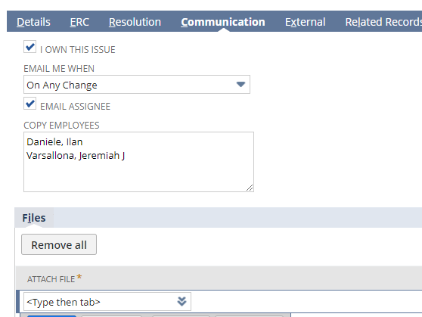

Install CBORD
It has POS.
Install CBORD gold development for odyssey, and then modify the scripts (CSgold handler express file, and the files that this file is pointing to) according to the API sent. Connect to odyssey to environment, do not use syracuse credentials, only cbord.

Leer documentacion enviada.

CBORD is already install
CBORD gold tender

Begin
Stage a workstation
Crear usuario:
List -> Employees -> Employees: crear mi usuario, y en custom poner en RA operator ID el operador que quiero:
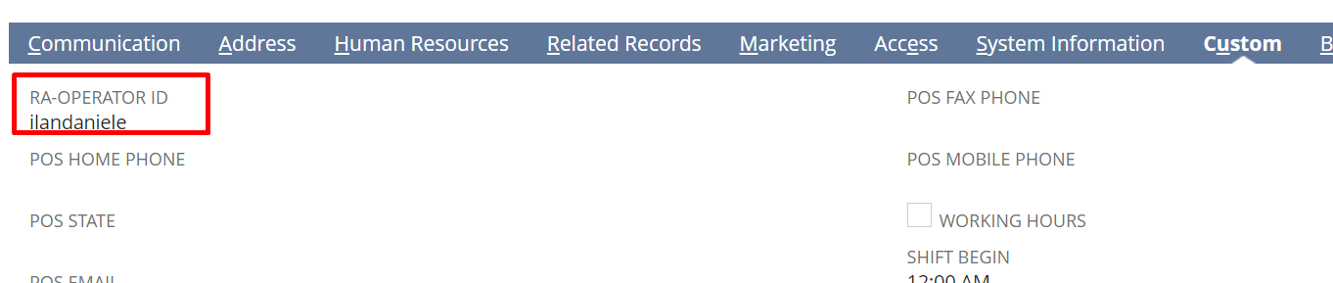
Guardar y después para iniciar sesión poner user y contraseña el mismo valor de RA operator ID y me pedirá cambiarlo luego.

Amount due -> run gold tender, si da error,

Looking at CBORD Odyssey, see what is missing on the document
Cuenta de syracuse
Customization -> List, Records & fields records -> Record Types:
Search for record type: “Suite Adapter – Log” -> View Records

Tengo que correr cbord gold, me va a dar una url
Y esta va a ser el json, pero este no es de cbord gold, tengo q correr cbord gold para q aparezca:
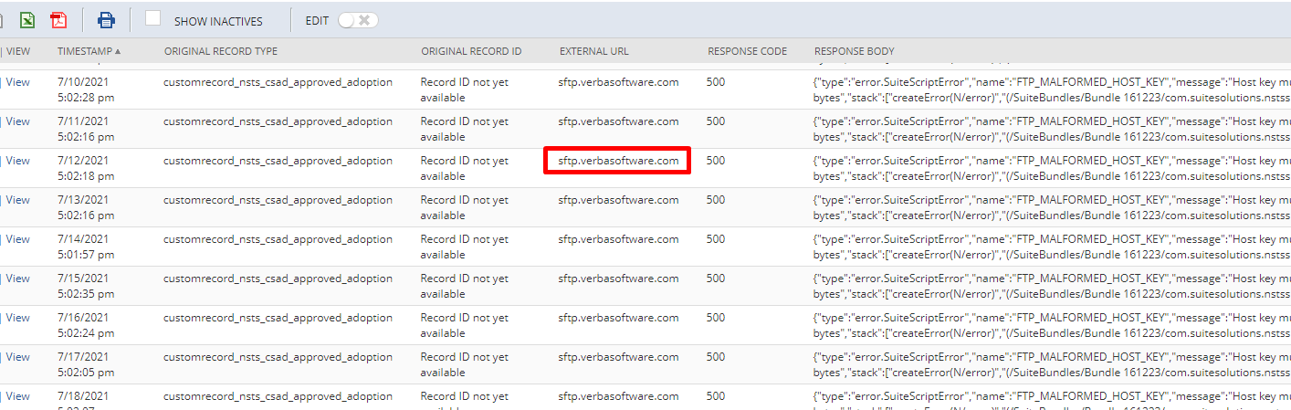
En vez de verbasoftware me va a aparecer cbord gold.
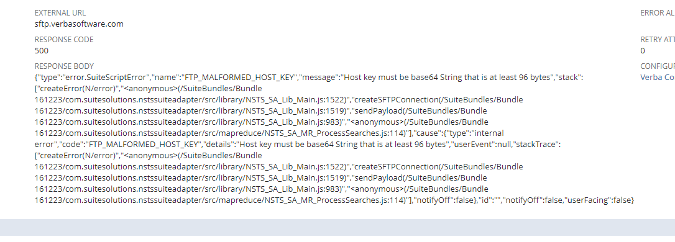
Change configuration ->
Primero hacer el stage de la register
https://4510125-sb1.app.netsuite.com/app/common/custom/custrecordentry.nl?rectype=84&id=401

